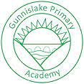
What are we learning in

Lusty Glaze this term? September 2021
Important things to remember this term!

Our PE days are:
Friday
Turn up in PE Kit

Water bottles welcome in class.

Please remember to read with your child at home as regularly as possible. They will be bringing home new reading diaries very soon.

Practise your times tables.

Dear Parents/Carers and children,

Welcome back after the summer, I hope you all had a good break. The children have settled well into their new class and it has been lovely to see them all.

This term our Curriculum Topic is:

Would you like to live like a Stone Age Hunter?

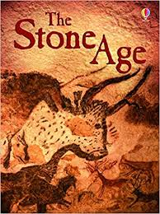
All of the work that we do during the Autumn Term will link to our History and Geography topic: The Stone Age.

We will be finding out about life during this period of History and comparing it to the life that we have today.

Our Art and Design projects will involve recreating cave paintings and designing and making large paintings of Stone Age people.
During literacy we will be learning all about the life of a Stone Age Hunter and all of the activities will be inspired by this fabulous non-fiction book:
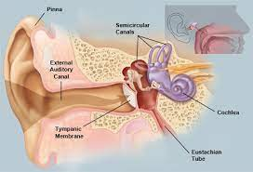
Our Science focus this half term will be Rocks. Science and Music will be on a Thursday and will be taught by Miss Owen.

It is going to be a packed half term. You can help support your child in school by reading with them as often as you can, talking to them about what they have been learning about in class and helping them to learn their times tables. We will be starting a new reading challenge in the next couple of week called Karate Reading, please look out for information on this.

Any questions or concerns please do not hesitate to come and find me at the end of the school day or make an appointment via the office. I have sent out seesaw login information. Seesaw is an excellent way for you to contact me, see examples of your child’s work and to also share photographs of things that they have done at home as well.

Kind regards

The Year 3 Teaching Team

Mrs Wood, Mrs Wright, Miss Owen, Mrs Garwood and Mrs Johns

Keep your eye out for notifications and updates on the schools facebook page or website.

www.delawareprimary.co.uk

