Questions children pose – These should be answered through the lessons

Mrs Wood, Mrs Marshall,

Main focus:

When was the Stone Age?

What was it like to live like a Stone Age Hunter?

Where did Hunters live?

What did they eat?

What do historical artefacts tell us about this period in History?

Could you survive this life in this period of time?

**Questions selected by the class:**

**Launch Question – Autumn Term 1 – YEAR 3/4**

**Would you like to live like a Stone Age Hunter?**

Links to English/Maths.

Writing a diary and writing instructions

Maths: ordering dates on a timeline.

Text: for Recipricol Reading and other literacy activities.

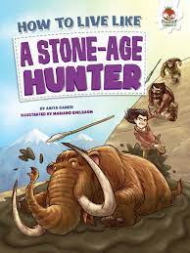

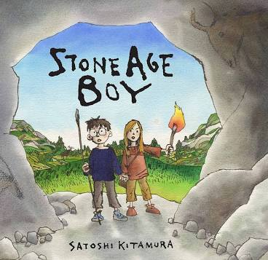

Opportunities outside the classroom? Forest schools outdoor cooking over a fire.

Objectives you plan to cover: (taken from the Trust progression skills ladders and NC)

Science: Rocks (Year 3) Sound (Year 4) SC1 objectives

History: YEAR 3

* Identify the difference between primary and secondary sources ·
* Use primary and secondary sources as evidence about the past ·
* Ask questions and find answers about the past from a range of sources such as ‘how did people…?’ what did people do for….’
* Recognise the part that archaeologists have had in helping us understand more about the past
* Identify similarities and differences between different periods e.g. social, belief, local, individual
* Use information given to describe key features of a time period

**YEAR 4**

* Analyse and evaluate primary and secondary sources to collect evidence about the past ·
* Ask questions and find answers about the past, from a range of sources, evaluating the reliability
* Describe and order significant events and dates on a time line using prepositional language
* Research what life was like and the key features of a given time period

Geography: Year 4

* Consider how physical geography impacts on land use, trade links, economic activity and types of settlement

Art/DT: · Year 3

* Know how to use sketches to plan and develop ideas ·
* Control a pencil to produce a wide range of tones and patterns ·
* Draw from observation in large and small scale
* Year 4
* Start to develop own style using explorations and experimentations from sketchbook ·
* Experiment with drawing techniques to support their observations ·
* Know how to create a sense of proportion in a drawing

Computing: Year 3

* Find relevant information by browsing a menu.
* Search for an image, then copy and paste it into a document
* Use ‘save picture as‘ to save an image
* Copy and paste text into a document
* Begin to use note making skills to decide what text to copy
* Year 4
* Use different search engines ·
* Use note-taking skills to decide which text to copy and paste into a document
* Recognise that information on the internet may not be accurate or reliable and may be used for bias, manipulation or persuasion ·
* Understand that the internet contains fact, fiction and opinion and begin to distinguish between them

**Separate planning – PE / Music**

**PSHE -**

**RE – How and why do people try to make the World a better place?**

MUSIC:

Why have you chosen the question? Curriculum coverage

Child interest led –

Local events – N/A

**Key Vocabulary:** **pre-historic, Neolithic, archaeology, excavate, nomadic, period, artefact, reliable, un reliable, settlement, cannibal, clan, domesticate, Homo sapiens, hunter gatherers, lichen, mineral, Nomadic, ochre, prehistoric, quarry, tinder**

**cave painting, tribe, throwing stone, evolve, flint, throwing stone**