What are we learning in Fistral class this term?
Autumn Term
September 2020
Important things to remember this term!

Our PE day is a Tuesday
children can wear PE kit to school on this day.

Regular active breaks will happen throughout the week.

Children can bring a drink into class in a sealed plastic drinks bottle.

Reading will take place in school and books will come home but we won’t use reading diaries at the moment to avoid sending too many things between home and school. If you can send any reading related questions or comments via seesaw that would be great.

During this term there will be no tuck shop available at break times but KS1 children are entitled to free fruit so will be provided with a healthy snack.

Dear Parents/Carers and children,

Welcome back, I hope that you have all had a wonderful Summer Holiday. It has been so lovely to welcome the children in Year 2 back to school after such a long period of time away from school.
Fistral class have already settled in brilliantly and made an excellent start to the academic year. It is nice to see new friendships developing and so many happy faces in the classroom. I am excited about the year ahead.

This term we will be learning about:

To Zoo or Not to Zoo? (Animals)
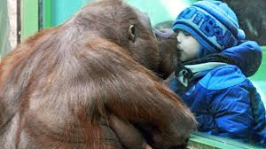

We will be researching animal habitats, finding out about food chains, sorting and classifying animals, creating animal art and music and answering lots of the questions that the children came up with today when we discussed what they would like to learn about. All of our literacy work will also be linked to this topic.

.

Kind regards,

Miss Evans, Mrs Cansdale and Mrs Hannaford.

