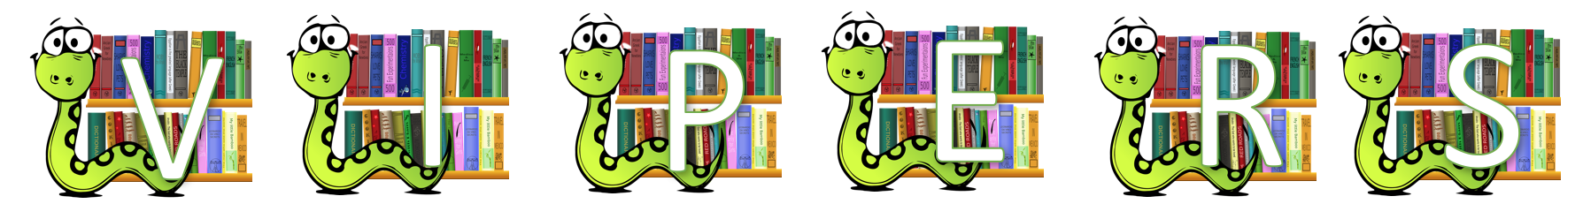

Text Title: King Midas: The Golden Touch
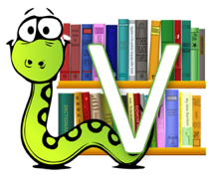 | Can you find another word or meaning for rich?  (synonym)
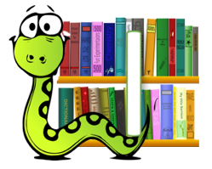 | How would you describe King Midas and why?
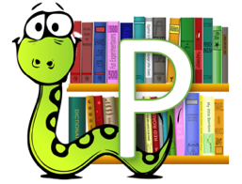 | What do you think will happen to King Midas and his family? How would this happen?
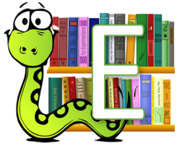 | How can do we know that King Midas grew tired of his power? Find and Copy a phrase from the text.
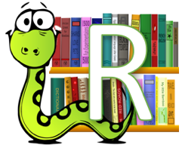 | If you were King Midas, would you go near your daughter? Explain your reasoning?

Pages 8 to 16
Text Title: Aladdin and the Enchanted Lamp by Philip Pullman
Pg. 8 What does ‘idle’ mean?
Pg. 8 List the words/phrases that tell us that Aladdin is not a well behaved child.
Pg. 10 Which word tells us that Aladdin was surprised?
Pg. 10 How do we know that the Moor was rich?
Pg. 12 Why was Aladdin’s mum suspicious of the Moor?

 | Who has read/heard the story of Aladdin before? What do you think will happen in this story?
 | Pg. 12 Find an example of ‘show not tell’ that reveals the religion of the Moor.
 | Pg. 13 How long did the Moor say he spent in the desert?
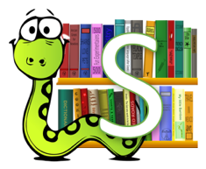 | Write what has happened so far in no more than five sentences.

Prior to reading: Experience – research bazaars and haggling
Pages 17 to 24
Text Title: Aladdin and the Enchanted Lamp by Philip Pullman
Pg. 22 What does ‘wonders’ mean in this sentence?
Pg. 20 Why was Aladdin’s step shaky?
Pg. 19 What do you think Aladdin will find inside?
Pg. 17 Find the simile. Why has the author used these words? What effect does it have?
Pg. 20 Have you read/heard/seen a different version of Aladdin? How is this version different?
Pg. 20 What colours were the flowers of the oleander trees?
Draw a picture and label the setting inside the garden of wonders.

Prior to reading: Experience – compare setting/theme (Garden of Eden/theft)
Pages 25 to 40

Text Title: Aladdin and the Enchanted Lamp by Philip Pullman
Pg. 26 ‘...the passage was blind…’ What does this mean?

Pg. 32 Why does Aladdin’s mum want the jinnee to go away?
Pg. 35 What is ‘wrong’ with Aladdin?

Pg. 27 What is the figure Aladdin can see?
Pg. 28 Jinnee of the Ring. Discuss differences/similarities to the Genie of the Lamp.
Pg. 39 The Sultan says he’ll listen to Aladdin’s mum even though his advisor says she doesn’t matter. How does that make the reader feel about the Sultan?
Pg. 26 Find and copy the alliterative sentence.
Pg. 35 What does Aladdin discover about people?
Draw a story map of this section of the story in no more than three pictures.

Prior to reading: Experience – research precious jewels (rubies, emeralds, sapphires, pearls and amethysts) and stones (lapis lazuli, onyx and marble)
Pages 41 to 56
Text Title: Aladdin and the Enchanted Lamp by Philip Pullman
Pg. 54 Which word tells us the Moor is feeling really pleased with himself?
Pg. 45 Why did the Grand Vizier snarl?
Pg. 50/51 What’s the Moor going to do to trick Aladdin?
Pg. 48 Does this scene (the princess seeing Aladdin and falling in love) remind you of any other stories? Discuss.
Pg. 50 Find and copy the words/phrases that tell us that the Moor is angry.
Write what has happened (in this section) in no more than five sentences.

Prior to reading: Experience – try Turkish Delight and research: https://en.wikipedia.org/wiki/Turkish_delight
Pages 57 to 65
Text Title: Aladdin and the Enchanted Lamp by Philip Pullman
Pg. 57 Can you think of another word that could replace ‘whooshed’?
Pg. 65 Why does Aladdin hide the lamp?

Pg. 57 What do you think Aladdin will do when they get there?
Pg. 58 How does the author show (not tell) they’ve gone a long way?
Pg. 59 What does the Moor call the princess?
Challenge: tell this story to someone you know.

