SPAG.com

Log-in details

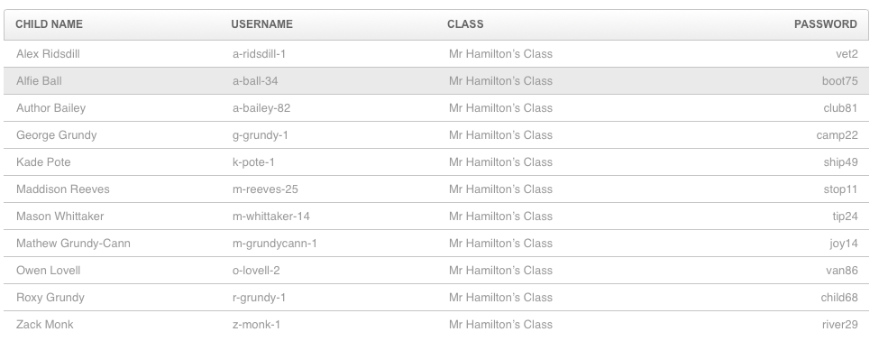
Class 2

