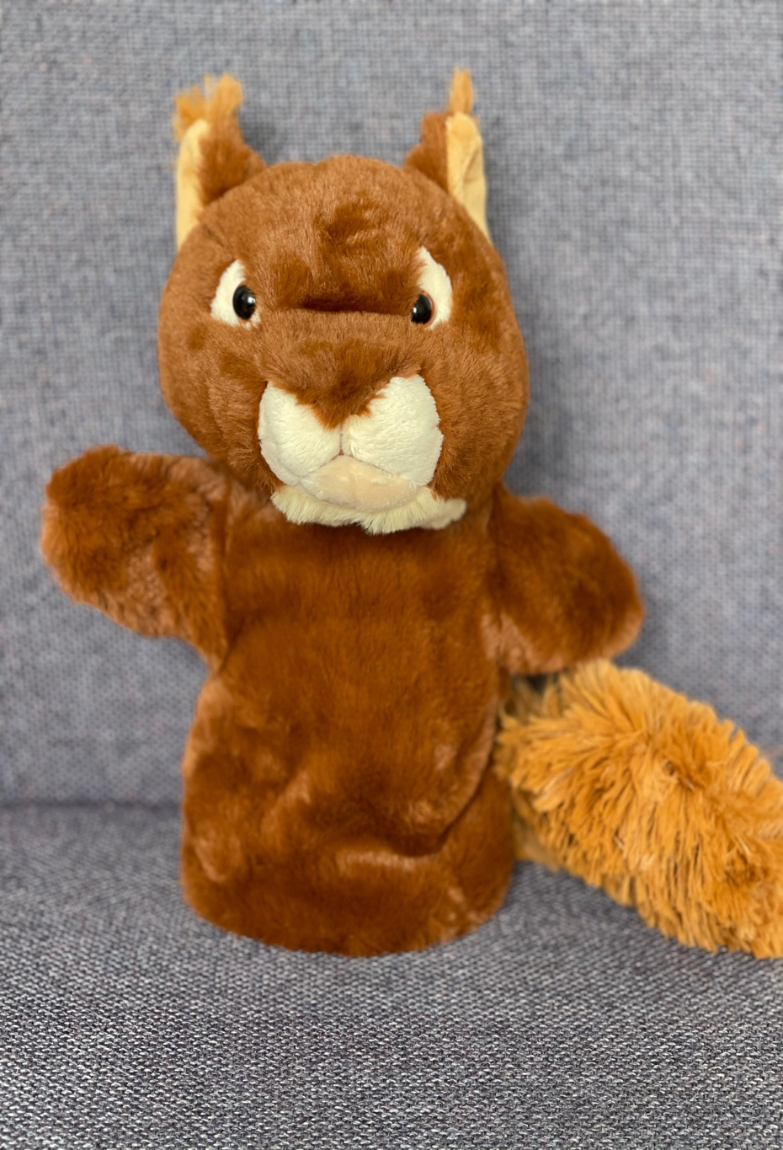
Sid
The Summariser Squirrel
He can summarise what he has read in his own words.
The most important ideas are….
This story takes place in ….
The main characters are….
First….Next….Then….
The problem in this story is ..… it is solved by ……

