Clara
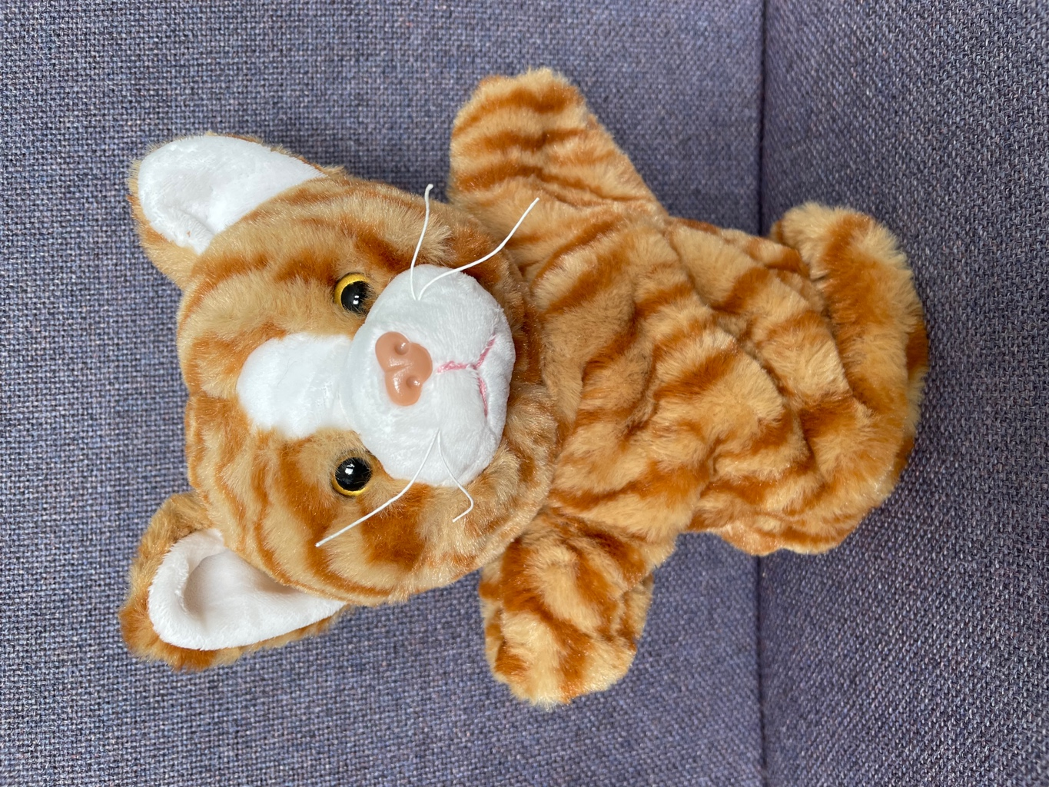
The Clarifier Cat
She checks understanding as she reads.
What does this word mean?
Do I understand this sentence?
Am I confused by what I have read?

